

SIMULATION OF A UNICYCLE-LIKE VEHICLE
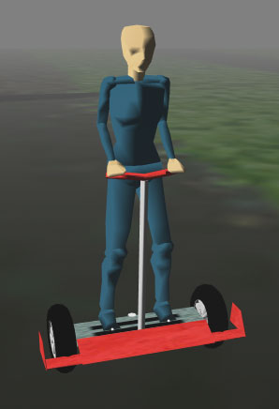

Abstract
This report contains a description of the work and results of teamwork to model programme and visualise of a vehicle very similar to the means of transportation for humans called Segway. The aim was to fully programme the vehicle in action physical correct in the programme language C++ and OpenGL.
The result was a slightly reduced prototype of the aim.

SIMULATION OF A UNICYCLE-LIKE VEHICLE 1
Abstract 2
1. Introduction 4
1.1 Background 4
1.2 Aim and question of issue 4
1.3 Presentation of a problem 4
1.4 Restrictions 5
1.5 Method 5
1.6 Sources 6
2. Principles of the vehicle 7
2.1 Physical background 7
2.2 Regulator 8
2.3 Steering 9
2.4 Simulation 9
2.5 Steering device 10
2.6 Speed and Pole placing 10
3. Result 11
4. Discussion 12
4.1 The group environments 12
4.2 The technical part 12
5. Reference 13
6. Appendix 13

1. Introduction

1.1 Background
In the course TNM032 at the University of Linköping, campus Norrköping, the third year’s students of Mediatechnology and engineering was allotted to make an animation of a physical system. During the project the students will work in small groups, and every group elects their own project to carry out. A supervisor, with whom the groups can discus their upcoming problems with, will be available. This group consists of four students, and managed by Anna Lombardi.

1.2 Aim and question of issue
The aim was to complete the project with a physically correct result and reinforce our understanding for model building and basic automatic control theories.
The main task is to determine whether the basic model is sufficient to build the project upon; that is to say if it will be correctly solved physically. //Alla såna här radbrytningar?
Since we are media technology students, a part of the emphasis is also be put on the graphical
representation. The animation must look attractive to the viewers, even thou this part of the project is not the main concern.

1.3 Presentation of a problem
The first model was a normal circus unicycle with just one wheel. This was however a too subtle task to complete, while there still are not any practical research on automatically control even an ordinary bicycle. The problem was therefore reduced to a vehicle similar to a Segway.

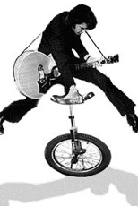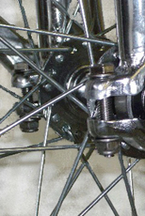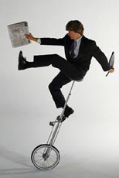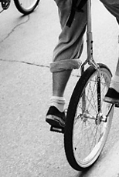
FIGURE 1: The first aim that never became completed, a unicycle.

The vehicle is controlled by a few simple rules:
Increase speed: lean forward
Decrease speed or break: lean backward
Turn left or right: Make the wheel on the desired direction move slower
Then there are the forces of physics involved: friction and gravitation.

The most important issue is the forward and backward interaction associated with the linear positive and negative acceleration. The second issue is the turning left and right implementation.

The main assumption was, because of the forward and backward motion, that a segway model basically is an enhancement of the famous inverted pendulum problem.

1.4 Restrictions
To keep the amount of work within a reasonable limit, the group decided to make some restrictions and not make the vehicle exactly as complicated as it is in actually fact.

- All the equations were made linear while it is easier to calculate estimations of the physics then exactly correct physical phenomenon.
- A driver in reality can do is to make such a brusque turn with the vehicle so it actually turns around its ones centre axis. This issue will be more discussed later on in the report hence the formula that the group uses for the estimations for turning the vehicle.
- The animation of the world is just simply a plane. the landscape does not contain any topological or other objects that would require advanced collision management. It is impossible to leave the ground with the wheels.
- For the computer graphics the group decided to make it as simple as possible to not slowdown the programme (the aim of the course is not to make spectacular graphics).

1.5 Method
To make the advance of work as fast and smooth as possible the group decided to work most of the time as a team so that every one could participate in all work. The group started out with some simple sketches on a piece of paper. The goal was to find out the physical influences and in that way be able to calculate all the mathematical formulates that will be needed for the programming part.
During the programming part of making the vehicle the group decided to use the programming language C++ with legible visual representation using OpenGL. The reasons to use C++ are many. In the first place it is an important language to learn on the whole. Then it is more fun and instructive to use a program language instead of using an already made program to reach the same kind of result. It may even be easier while it can be strenuous to find what is needed in a program like Matlab. Another reason that made the choice of C++ was the ability to combine C++ with OpenGL. OpenGL is for the group members the most known way to program graphics.
The well-known programe3D Studio Max was used to model the vehicle. The model is very simple to not slowing down the fully finished modelling program with heavy graphics.

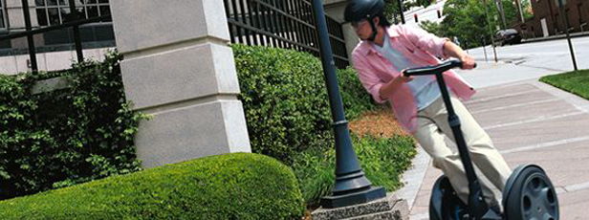
FIGUR 2: A Segway used in the city

1.6 Sources
To make this project the group is in need of different sources. They are all rather reliable but are not absolutely flawless. The main source is the laboratory experiment booklet made by Gunnarsson, Svante & Norrlöf, Mikael & Nordström, Kjell (2003), called Laboration i Reglerteknik, Reglering av inverterad Pendel. All students have earlier done this laboratory experiment and know it is working as it should.
Another source frequently used is two different sites on the Internet, nehe.gamedev.net and www.gametutorials.com. The Internet isn’t always a reliable source of information, the freedom and mixture of people and opinions can lead to wrong conclusions and distorted facts. But it has always been a large community for computer interested people, and also a place to brag about smart ideas and programming solutions. Therefore is the amount of good programming information extensive, and since computer programming isn’t, in most cases, an opinion based topic and the code published is easily tested can Internet be considered a good learning aid for programming.

To understand how a Segway is working when it is in use the site of the company that have them fore sale, www.segway.com. This is a commercial site with a purpose to sell Segways.
Some literature made by Ljung and Glad called Reglerteknik Grundläggande teori (1989) and Modellbygge och Simulering (2004), both books in second edition, was used during the working process. Both books are easy to understand and explain the theory in a concrete way.
For understand the physics relationships the group used a book called University Physics, Revised Edition written by Benson, Harris (1995). This book is very typical American where the author is paid per page and therefore a lot of irrelevant facts. The way it is written is also sometimes very fuzzy, over all a frustrating reading.
In addition to all written information there will also be a possibility to discuss issues with the very competent supervisor Anna Lombardi, whom works as a senior lector at the University of Linköping, campus Norrköping.

2. Principles of the vehicle

2.1 Physical background
The basic of the simulated system is two masses, connected by a stiff (massless) rod, in a gravitation field. If the first mass is placed on ground level and the second a bit above, the second mass will begin a fall as the gravitational force acts on it. The rod between the masses will transfer some of the energy directly to the first mass and, assuming that the ground friction is small, make it moves. The system rotates, moving the first mass along the ground and the second mass in a near arc until the ground absorbs all energy. If the second mass is located above the exact location as the first mass rests on the gravitational force will act in the direction of the rod. This means that all energy is transferred to the ground, none is left to make the mass move.
Mass 2
Mass 1
Figure 3: The physical system, with the gravity acting on the second mass causing via the rod a force acting on the first mass

This state of equilibrium is seldom achieved, as the slightest displacement of the mass will get some energy to cause a movement that won't stop until the mass hits the ground. To prevent this, something can slide the first mass on the ground and in case of a disturbance try to position it directly under the second mass. This is called a regulator. By that means maintains the equilibrium. When this moving system is obtained is the step not far from a vehicle. The movement of the second mass can be controlled by slight pushes or by leaning the rod. The regulator will then slide the first mass in the same direction. If the disturbance on the second mass or the rod continues, will the first mass maintain a movement in the regulators pursuit for equilibrium. Thereby attains a contraption with controllable motion, a vehicle much like the Segway.

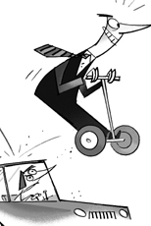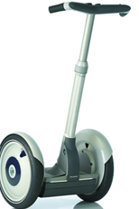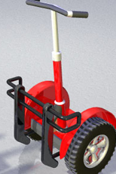
fIgure 4: The vehicle Segway for human transportation.

2.2 Regulator
The regulator is a critical part in such a vehicle and should not be a human being, both by ethic and efficiency reasons. Therefore should it be a machine with sensors for the different states of the system, as velocity of the mass or angle of the rod, and a motor turning wheels connected to the first mass. To construct this machine must all, or at least enough, physical characteristics of the system and relationships between them determines.

This kind of model and its regulator is described in the laboratory booklet (Gunnarsson & Norrlöf & Nordström, 2003). The variables of the system can be obtained from the earlier mentioned laboratory. Since that model is not a description of a vehicle, but a sliding cart on frictionless ground, it must be adapted. The two masses can be described as the vehicle and its driver, the rod, will thus be a handlebar for the driver. As a more physical correct model is created will it be necessary to implement a friction constant between the ground and the wheels of the vehicle. Therefore obtains these variables:

l = Length of the handlebar, constant.
M = Mass of the vehicle, constant.
m = Mass of the driver, constant.
f _{θ} = Friction at the rotation of the handlebar, constant.
f_{μ} = Friction between ground and wheels, constant.
g = Gravitation, constant.
x(t) = Position of the vehicle, time dependent.
θ(t) = Angle of the handlebar from upright position, time dependent.
Figure 5. Variables

The relationships are derived from basic physical equations as in laboratory booklet (Gunnarsson & Norrlöf & Nordström, 2003). The results have been obtained with some approximations, most important is the approximation for small angles, i.e. where cos(a) = a. This makes the system behave correct when the rod is leaning at a small angle but can cause strange behaviours for larger. The benefit of this approximation is that the system can be described by linear equations, which makes it much easier and faster to solve. As the constant and their relationships are found the mathematical description of the whole system can be shown as a state model. The time dependent variables can be obtained for each period of time.
This state model is similar to the inverted pendulum, in the laboratory booklet (Gunnarsson & Norrlöf & Nordström, 2003), except for the extra frictional constant f_{μ}. This model is the heart of the implemented C++ code.
$\frac{d}{\text{dt}}\begin{aligned}\left[x_{1} | \right]\left[x_{2} | \right]\left[x_{3} | \right] \\ \end{aligned}$.
Figure 6. The state space model. $x_{1}$ is the position, $x_{2}=\overset{\text{.}}{x_{1}}$in other words the velocity. $x_{3}$is the angel and $x_{4}=\overset{\text{.}}{x_{3}}$is the angular velocity.

The program makes the vehicle fall if it is tiling in more than 45 degrees. This restriction is necessary because of the linear system. The original sin function and the x function differ too much after this angle (the linear model becomes invalid for large angles).

2.3 Steering
Because there is just one axis, the steering is not controlled by a steering wheel. Instead, the vehicle turns left by making the right wheel move faster than the left, and the other way around. The modelling of this part began with viewing a swung motion like a sphere with a certain radius. The smaller the radius, the sharper is the turn. The overall speed is determined by the main system, and the speeds of the wheels are independently calculated for the right simulation from our formula that we have derived from these circles.

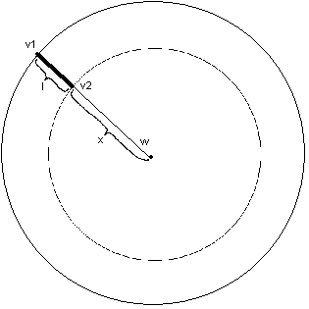 | v₁=outer wheel speed  v₂=inner wheel speed  v_{m}=vehicle linear speed  w=angular velocity  l_{A} = axis length  x=turn radius  $$\begin{aligned}\left\{v_{1}=(x+l)w | \right.\end{aligned}$$  where  w= v_{m}/(x+ l_{A} /2);
FIGURE 7: An illustration of how the vehicle make turns.

In the simulation, we do not allow the vehicle to turn around its own axis which would make one wheel move backward at small speed. That is a simplification, because a real segway allow such motion. The known variables in the beginning are the linear speed in the middle of the axis and the radius of the swung that is dependent of the speed by the formula

radius = abs(0.2*v ± a)

That restriction is because we do not want the centripetal force to take a dominant role. That would make the segway fall outwards when turning too sharp in high speed. The a term is the length of the axis and v is the speed. The length term is necessary to prevent “around-axis” turns.

2.4 Simulation
The only simulation method used is the forward Euler method. This is indeed the most used simulation method in computer games, where to step length can be made appropriate small.

Euler forward:

X_{n+1}=X_{n}+d*X_{n}

2.5 Steering device
The four arrow buttons are used, with the up/down as leaning buttons and right/left as turning buttons. In case of the up/down button will a little value be added to the angle for each time period the button is pressed. This causes the vehicle to lean more the longer the button is pressed, which results in increased velocity. Left/right buttons triggers a variable to be true indicating left or right turn. For each time step will then the corresponding turn be calculated. When the button is released will the variable be false and thereby indicate that the vehicle is going straight ahead.

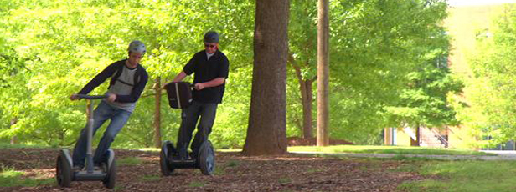
Figure 8: Off-road with Segways.

2.6 Speed and Pole placing
The trade-off involving placing poles in the closed loop system became obvious when working with speed.
Many trials were made on this task. The poles finally used lies inside the circle around the origin with radius 2. Higher poles tended to control to fast, the vehicle could not accelerate during a longer time before it got back to its vertical position. Lower poles made too big oscillations, outside the angle boundaries.

3. Result – Micke
Allt blev linjärt.

4. Discussion

4.1 The group environments
The programming in C++ and OpenGL went without greater obstacles. Part of the code needed for the project that was out of knowledge or time to learn could be obtained from tutorials at different, very user-friendly, sites on Internet (nehe.gamedev.net, 2004 and www.gametutorials.com, 2004). This pertains most to the ASE loading method and texture mapping.

Only a fourth of the supervision time was consummated. The reason for this was probably the fact that we did not need all the available help, but language barrier can not be ignored. It is always harder to discuss advanced topics using English, than using the native language. Despite this, Anna Lombardi was indeed much needed in a few decisive questions.

The group enjoyed the work and finds the result satisfying. There have been no huge imposing obstacle or arguments in the team work witch have made a certain flow in the work. However, it is more convenient if every one in the group has the same level of knowledge about the actual task. In this case programming in C++ and OpenGL was a issue of unequal knowledge. All the group members had very different experience and familiarity about programming in C++ and using Open GL. Because of this, the amount of work during the programming was very unbalanced distributed. Even thou every one was sitting in a group in front of the computer, those who knew programming made the most of the work. This is of course not a good way to deal with the problem while it makes one half of the group loaded with work, and the other in lack of edification.

A solution to this problem would have been to split the work tasks and work more individually. It will unfortunaly pose the problem that it will take more time than existing for this task for those whom do not knew programming.

Another solution is to make sure that everyone in the group has equal knowledge from the beginning. In this case we could have been using Simulink or 20sim instead, but that imposes, according to the group, a less exciting work.

4.2 The technical part
The goal was to reach the speed of 20 km/h, cause this is a realistic speed for a Segway. The final result of the project reaches just about 8 km/h, which is not totally satisfying. The group tested a lot of different pole placement to increase the speed, but did not achieve a better result. Therefore it is very uncertain that higher speeds are possible to maintain. This shows the inverted pendulum controller is not the best model if speed is an important issue for the vehicle.

As mentioned earlier, the group finds the result satisfying, but not excellent. There are a couple of things concerning the physics, which could have been carried out better and made the program more enjoyable.

The reality as the original model is non-linear, but we could not have done the project this
way, while non-linear control is outside the scope of the course.
The friction represented in the system is now just a small force backward depending on the speed. This could be seen as a combined sliding and air friction, without concerning rolling friction from the wheels.

The main shortcoming of the final model is the human contribution. We are neglecting totally that the rider does have a great impact on the vehicle. It is not only the automatic controls of the vehicle that make it move. A great part of the balancing act is a result of what and how the rider controls the vehicle. For example, with leaning also from side to side, it is possible to make sharper turns without falling due to centripetal force.

The steering with arrow buttons was easy to implement in the code, but the leaning function becomes very stiff. If the vehicle would have been steered by a joystick, the leaning would have been more controllable and other speeds than the top speed would be possible to maintain for a longer time.

Even thou we, the working group, are aware about these facts, do we not consider them so important that we spends more time to change them towards more realistic friction. One interesting question is whether it is always demanded to model in a physical correct way. Evidently it is of a greater impact that it is totally physical correct if the model represent something that later on will be produced or have an effect on a system in use. Hence our program tends to lean more towards game oriented type of simulation; therefore it is just for the eye pleasure and interaction feeling. Then we consider it is better to make a spectacular animation model instead of complicated but correct physical background.

5. Reference
Benson, Harris (1995), University Physics, Revised Edition, United States of America: Wiley

Glad, Torkel & Ljung (1989) Reglerteknik Grundläggande teori, second edition, Sweden, Lund: Studentlitteratur. ISBN 91-44-17892-1

Glad, Torkel & Ljung, Lennart (2004), Modellbygge och Simulering, second edition, Sweden, Lund: Studentlitteratur. ISBN 91-44-02443-6

Gunnarsson, Svante & Norrlöf, Mikael & Nordström, Kjell (2003) Laboration i Reglerteknik, Reglering av inverterad Pendel, Sweden, Norrköping.

Merkel, Magnus & Andersson, Ulrika & Lundquist, Malin & Önnegren, Britta (2003) Lathund för rapportskrivning, Sweden, Linköping: Linlöpinigs universitet

Nehe Productions
http://nehe.gamedev.net/

Gametutorials
http://www.gametutorials.com/

Segway
http://www.segway.com/

6. Appendix
Programkoden

